

**Addressing the Issues Faced by NHS Scotland**

**Case 2 – Group 4**

Tarek Buisson

Piyatida Sriwimon

Liyi Tan

Conor Mooney

Michael Patrick

Guy Neal

Contents

1. Introduction 3

2. Problems 3

2.1 Aging population 3

2.3 General Practitioners (GPs) 3

2.4 Cancer Patients 3

3. Promising Solutions 4

3.1 CyberKnife 4

3.2 Using AI Chatbot in Healthcare Industry 5

3.3 Cost of Building a Chatbot. 5

3.4 Electronic Health Records 5

4. Need for Big Data Analytics in Healthcare 5

5. Conclusion 6

6. Appendix 8

7. Bibliography 12

# Introduction

The NHS Scotland supports a population 5,436,600, the largest population on record according to the census Scotland. (Scotland’s Census, 2023). Staff shortages, government cutbacks and outdated system all lead to an increasingly inefficient and outdated healthcare system. This has worsened in recent years due to world events such as the COVID pandemic and the current economic climate, highlighting key areas failing within the NHS. Pressures faced due to the covid pandemic have led to widespread delays in vital operations and cancer treatments, with waiting times at a record high (‘Diagnostic Waiting Scotland’, 2022). Considering these issues, it is therefore vital that the government explores and implements new strategies for improving the NHS, as a preventative measure rather than a reactive one.

# Problems

## 2.1 Aging population

An aging population represents multiple future challenges for the NHS, with a burden of care increasing annually. Currently, there are over 1 million people over 65 living in the Scotland, and only 832,300 under the age of 15. (*Scotland’s Census 2022*, 2023). This continual aging of the population is estimated to increase by 50% by the year 2033. (Scottish Government, 2010). It has also been estimated that the dependency ratio, those requiring age related medical care, will increase from 60 per 100 to 68 per 100. (Scottish Government, 2010). This data highlights areas of increased demand within the NHS such as bed blocking and increased congestion in A&E. If the current care system is not adapted to support this increasing demand, it will likely lead to further disruptions across Scottish healthcare.

Approximately half of all public sector spending in 2010 was age related at 20.1% of GDP, with a projected increase to 26.6% by 2057 (see figure 1), with the largest increases coming from pension and health care spending. (Scottish Government, 2010). Adult social care in Scotland amounts to over 3.8 billion, of which age-related care amounts to 2397 million. (Feeley Derek et al., 2021) (see figure 2)

## 2.3 General Practitioners (GPs)

The United Kingdom ranks second to last in G7 countries regarding health expenditure as a percentage of GDP, with Italy being the only nation behind (the UK and Japan have exchanged positions intermittently). While the number of GPs has increased, there has been a decline in GP partners, a trend evident post-2015. (See figure 3). Compounding this issue, today’s GPs are faced with the challenge of accommodating a growing patient population. Since 2013, there has been an 11% increase in the average number of patients served by a GP, rising from approximately 1,500 to around 1,700 in 2022. Data available through the National Health Service (NHS) indicates a decrease in the number of GP partners in Scotland, dropping from 981 in October 2015 to 897 in October 2023. (See figure 4). Furthermore, there has been no significant change to GP numbers from 2017 to 2022, with the figure remaining the same while demand has only increased. (See figure 5).

2.4 Cancer Patients

Challenges arise as the number of GP partners and patients both increases, placing further strain on the already pressured healthcare system in the UK, particularly in Scotland. A prime example of this is the surge in cancer cases. Public Health Scotland reveals a 33% increase in cancer diagnoses between 2008 and 2022, with the current annual average of 30,500 cases projected to rise to 40,000 cases between 2023 and 2027. (ISD Scotland, 2015) Nevertheless, the final quarter of 2022 witnessed a decline in meeting the 62-day standard for urgent referrals to treatment. (See figure 6). During this period, only 72% of eligible individuals received treatment within this timeframe, a notable drop from the 84% achieved in December 2019. Importantly, the 95% target for this metric has remained elusive since data collection commenced in January 2012.(ISD Scotland, 2015)

# Promising Solutions

## 3.1 CyberKnife

In 2022, the then Cabinet Secretary for Health and current First Minister of Scotland, Hamza Yousaf, introduced the **National Radiotherapy Plan for Scotland**. Stressing the importance of the plan, he emphasized an allocation of £45 million for the enhancement of radiotherapy services throughout Scotland. This initiative aligns with **the Scottish Government's Recovery and Redesign plan of 2020**, which aimed to elevate healthcare standards in Scotland through a £114.5 million investment by 2023.

Action 38 of this plan stipulates that a national plan for Scotland's radiotherapy services, aiming to cure more cancer with an increase in access for more modern treatments. It will also increase access to research trials in all centres. To this end, Intensity-Modulated Radiation Therapy (IMRT) and Volumetric Modulated Arc Therapy (VMAT) equipment were procured. However, a more effective treatment method known as CyberKnife Technology could have been employed (Borowicz *et al.*, 2022). The history of CyberKnife technology in the UK dates back to 2010, and in Scotland, the first machine was acquired at Aberdeen Royal Infirmary in 2020, partly funded by a local charity. To provide a brief overview of the technology, CyberKnife is a non-invasive and incision-free treatment capable of addressing cancer and tumours throughout the body. The machine comes at a cost of approximately £3 million, with the following price structure observed in some nearby locations where it is available: United States: Up to $100,000; United Kingdom: €30,000 (primarily available privately); Poland: €8,000-20,000 (Poland is mentioned due to its popularity in medical tourism within the EU); Turkey: €10,000-15,000; Pakistan: Free (State Funded) (Flymedi, 2022)

Considering that the NHS covers healthcare treatment for UK residents, it is worth noting that a developing country like Pakistan offers this advanced facility for free. This prompts the question of why the UK government cannot adopt a similar approach. The cost-utility analysis demonstrated CyberKnife SRS to be a superior and cost-effective primary intervention for patients with metastatic spinal tumors, compared to conventional external beam radiation therapy. (Papatheofanis, Williams and Chang, 2009)Patients treated with CyberKnife SRS gained an additional net health benefit of 0.08 quality-adjusted life years, with CyberKnife SRS costing $1,933 less than external beam radiation therapy for comparable effectiveness. The incremental cost per benefit for this strategy ($41,500 per quality-adjusted life year) aligns with payers' willingness-to-pay criteria. (Papatheofanis, Williams and Chang, 2009)

This suggestion aligns with the Scottish Government's policies outlined in 2020 and 2022, presenting an opportunity to revolutionize the healthcare sector while also proving cost-effective in the long term, ultimately alleviating the strain on already overburdened healthcare facilities.

## 3.2 Using AI Chatbot in Healthcare Industry

Nowadays, in terms of healthcare, people try to use OpenAI and ChatGPT, to give them some medical advice, however, they are not officially used in terms of medical diagnosis nationwide. The artificial intelligence (AI) that has been used in the healthcare industry is designed to reduce the work and complexity of doctors. A possible solution to reduce GP pressure is providing the patients with initial stage diagnosis using AI-powered chatbot (Agnos, 2021) .

In Thailand, there is a startup that develop a preliminary stage of disease diagnosis application using AI technology called “Agnos”. Its purpose is to reduce the waiting time of the patient. It analyses a patient’s symptoms along with risk profile and provides appropriate health recommendations. The product had been tested with more than 100,000 cases with the collaboration with doctors in private hospitals in Thailand. (Agnos, 2021).

## 3.3 Cost of Building a Chatbot.

The estimated price for a custom AI system, ranges from US$20,000 to US$1,000,000. Looking further into this it was found that the minimal viable product (MVP) ranges from $8000 to %15,000. This shows the relative affordability of AI systems in for application in a health care setting (see table 1). This represents a viable solution within the means of the Scottish government. This when compared to the price of hiring more qualified GPs represents another possible route of saving for the NHS.

## 3.4 Electronic Health Records

Electronic health records (EHR) include all the medical history, data, and notes of a patient, which is freely accessible to other health professionals(NHS Research Scotland, 2023)(see figure 13). Scotland’s EHR was improved by the eHealth Strategy (2014-17) with plans in figure 11 and 12 in appendix(‘Position Statement on Electronic Health Records in Scotland’, 2015). Currently protected by Fair warning systems, a privacy breach detection system (wire business, 2016)This information was used by the Health Informatics Research Advisory Group (Scottish Government, 2015), which laid out a foundation for data analysis of EHR. This data and others, including the largest whole genome (*Topics | ISD Scotland*, no date)could be used for medical research.(Campbell *et al.*, 2022). As had been done in Israel which has been advocating EHR for 20 years, and recently set up TIMNA big data research platform in 2018 (Cormstock Jonah, 2019),with further plans to use AI to sift through this data. Notable medical breakthroughs, including Maccabi Healthcare connecting haemoglobin levels in blood to colon cancer, and Taliaz which used medical records to instantly and with 70%-80% accuracy the correct anti-depressant doses for a patient, which is twice as accurate as the last and saves months of experimentation (Tov Moshe Bar Siman, 2019). Moreover, in Denmark EHR is contained on a secure website and provides alerts if the system predicts medication complications, as well as cutting doctors administrative duties by 50 minutes a day (Harrell Eben, 2009).

# Need for Big Data Analytics in Healthcare

The evolution of healthcare has not only highlighted the need for rapid data access and analysis, but also for the ability to leverage big data for medical research. Cloud solutions, exemplified by platforms like Amazon Web Services (AWS), Microsoft Azure, and Google Cloud, present scalable, secure, and adaptable infrastructure for data streams coming from the likes of point-of-care (POC) diagnostics, AI chatbots and EHRs.

The adoption of cloud solutions can enable POC devices to gather, analyse, and utilize data more effectively. AI and machine learning can take the diagnostic process to the next level by enabling predictive device diagnostics to offer the capability to revolutionize the speed and accuracy of diagnostic results. For instance, the Apple Watch exemplifies autonomous operation and self-coordination with other products and systems, providing a glimpse into what future POC devices might look like. By making use of historical data collected across an entire fleet of devices, AI and machine learning can facilitate proactive service and repairs, leveraging insights from various instruments to enhance product performance and improve service support. The adoption of AI and machine learning in POC diagnostics not only holds the potential to improve healthcare outcomes but also offers opportunities for product differentiation and innovation.

While the adoption of cloud solutions presents a transformative opportunity, it is vital to consider cybersecurity and data protection regulations to ensure the confidentiality and security of sensitive health data. Therefore, cloud solutions must address security concerns related to electronic health records (EHR) and patient privacy, thereby facilitating their adoption for healthcare applications. Major cloud organizations, including Amazon, Google, and Microsoft, have implemented high levels of security on a global scale, and all communication between devices and the cloud can be fully encrypted and traceable through unique identifiers. Leveraging the cloud can bring about significant advantages, such as reducing the cost of goods sold (COGS) for devices by as much as 30%.(Valcke Christian, 2020)

Due to the growing adoption of cloud computing in the healthcare industry, primarily driven by factors like EHR, telehealth and POC devices, the global healthcare cloud computing market is estimated to grow at a CAGR of 17.8%, from $39.4 billion in 2022 to $89.4 billion in 2027. (Markets and markets, 2022). Therefore, to extrapolate market share with cost, there should be a17.8% increase in budget allocation for healthcare-based cloud computing every year.

# Conclusion

In summary, the healthcare system in Scotland is currently encountering various issues that have worsened since the COVID-19 pandemic. These challenges encompass an ageing population, a shortage of general practitioners, and an increase in the number of cancer patients and their waiting times. However, there are potential solutions outlined in the text that can address these issues and lead to significant improvements in the healthcare sector.

First, the National Radiotherapy Plan for Scotland, introduced in 2022, represents a promising step in enhancing cancer treatment and access to modern therapies. The implementation of cost-effective technologies like CyberKnife can alleviate the strain on healthcare facilities and improve the quality of care for cancer patients, as seen in other countries.

Additionally, the adoption of AI-powered chatbots can help reduce the burden on GPs by providing initial stage diagnoses. A startup in Thailand, Agnos, has demonstrated the effectiveness of such technology in reducing patient waiting times and improving healthcare recommendations.

Electronic health records (EHRs) offer a wealth of data that can be leveraged for medical research and improving patient care. Implementing data analytics and AI in healthcare, while ensuring data security and privacy, can lead to valuable insights and medical breakthroughs.

The adoption of cloud solutions and the integration of big data analytics in healthcare can further revolutionize the industry. These technologies can enhance diagnostic processes, improve healthcare outcomes, and reduce costs. It is evident that cloud computing is a growing trend in healthcare, and budget allocation for these technologies is essential to keep pace with the industry's evolution.

By considering and effectively implementing these proposed solutions, the healthcare sector in Scotland can strengthen its capacity to respond to the changing demands of its population and ensure the future sustainability of the healthcare system. Embracing technology and data-driven approaches can help address the challenges faced by the healthcare system and ultimately lead to improved patient care and outcomes in Scotland.

# Appendix

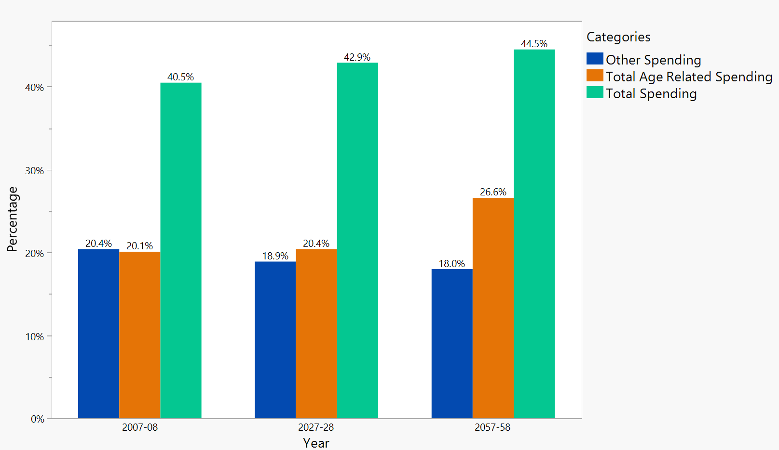

*Figure 1. Total age-related projected spending. Data taken from*

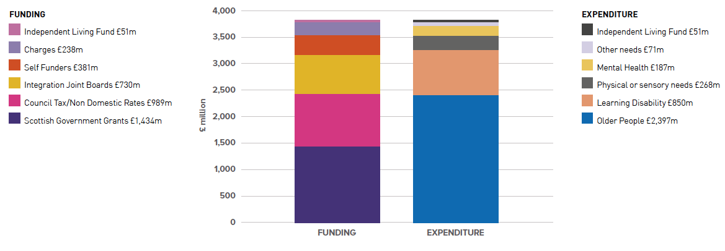

*Figure 2. Representation of adult social care budget Vs the expenditure.*

*Figure 3. Representation of increase in GPs Vs decrease in GP partners.*

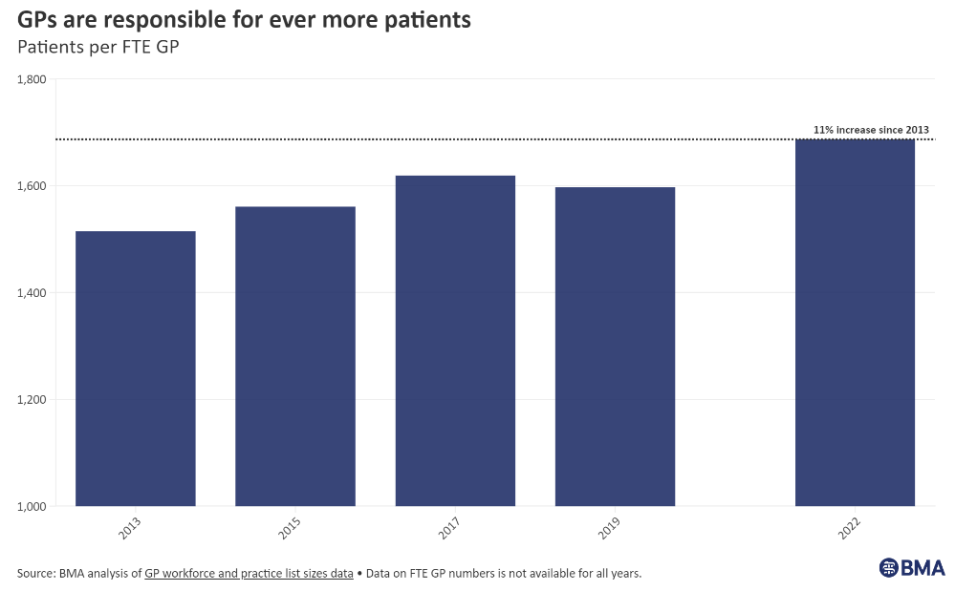

*Figure 4. Representation patient demand on GPs*

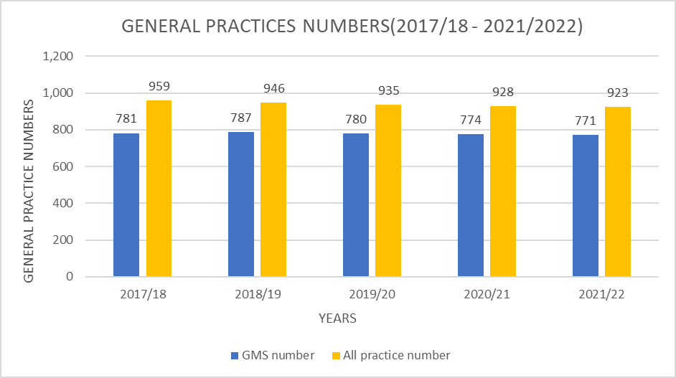

*Figure 5. Shows the number of general practices for each year in Scotland. There is no significant increase in the number of general practices. There was a reduction in the number from the year 2020/2022.*

*Figure 6. Increased cancer treatment waiting times.*

*Figure 7. How AI-powered Health Diagnostic Application, Agnos, works.*

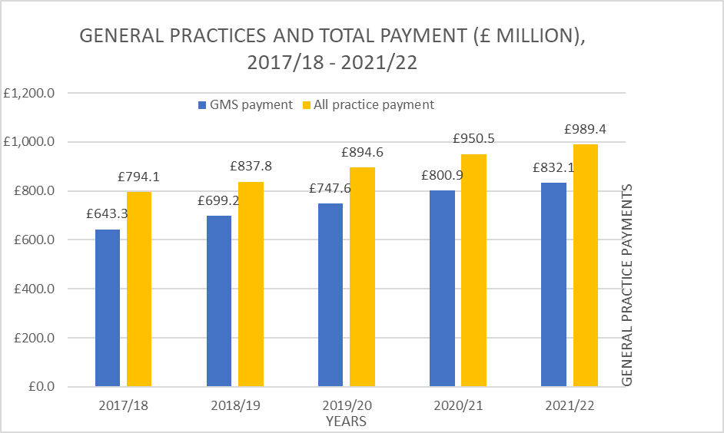

*Figure 8. Shows the cost of paying general practices for each year in Scotland. There has been an increase in the payments of general practices.*

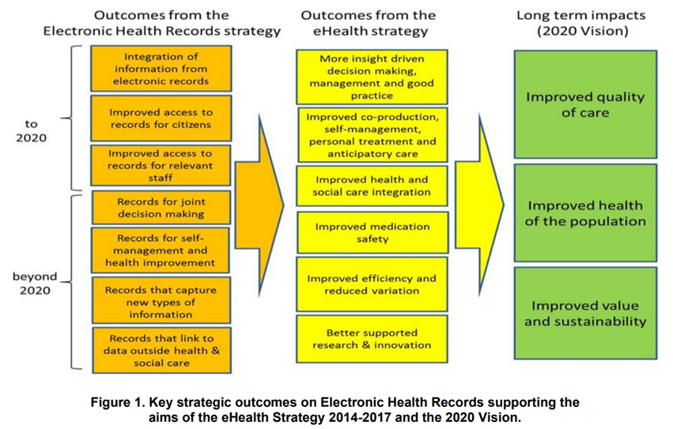

*Figure 9. Position Statement on Electronic Health Records in Scotland (no date, pg.4) Available at:* <https://archive2021.parliament.scot/S5_Public_Audit/Position_Statement_on_Electronic_Health_Records_in_Scotland.pdf>

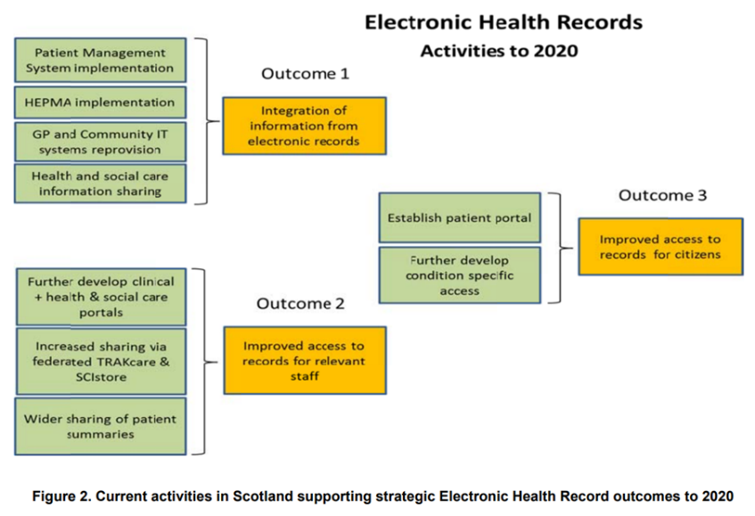

*Figure 10 Position Statement on Electronic Health Records in Scotland (no date, pg.5) Available at:* <https://archive2021.parliament.scot/S5_Public_Audit/Position_Statement_on_Electronic_Health_Records_in_Scotland.pdf>

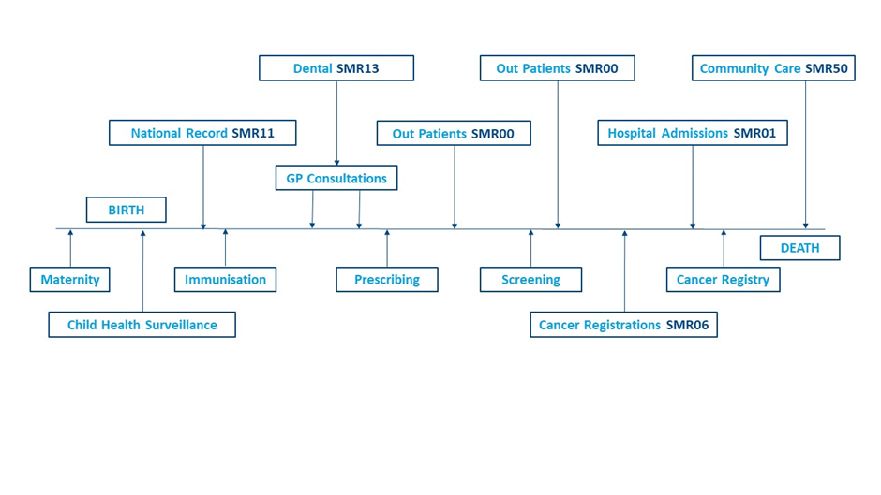

*Figure 11: NHS Research Scotland (2023) Electronic Health Records. Available at:* <https://www.nhsresearchscotland.org.uk/research-in-scotland/data/sub-page-4>

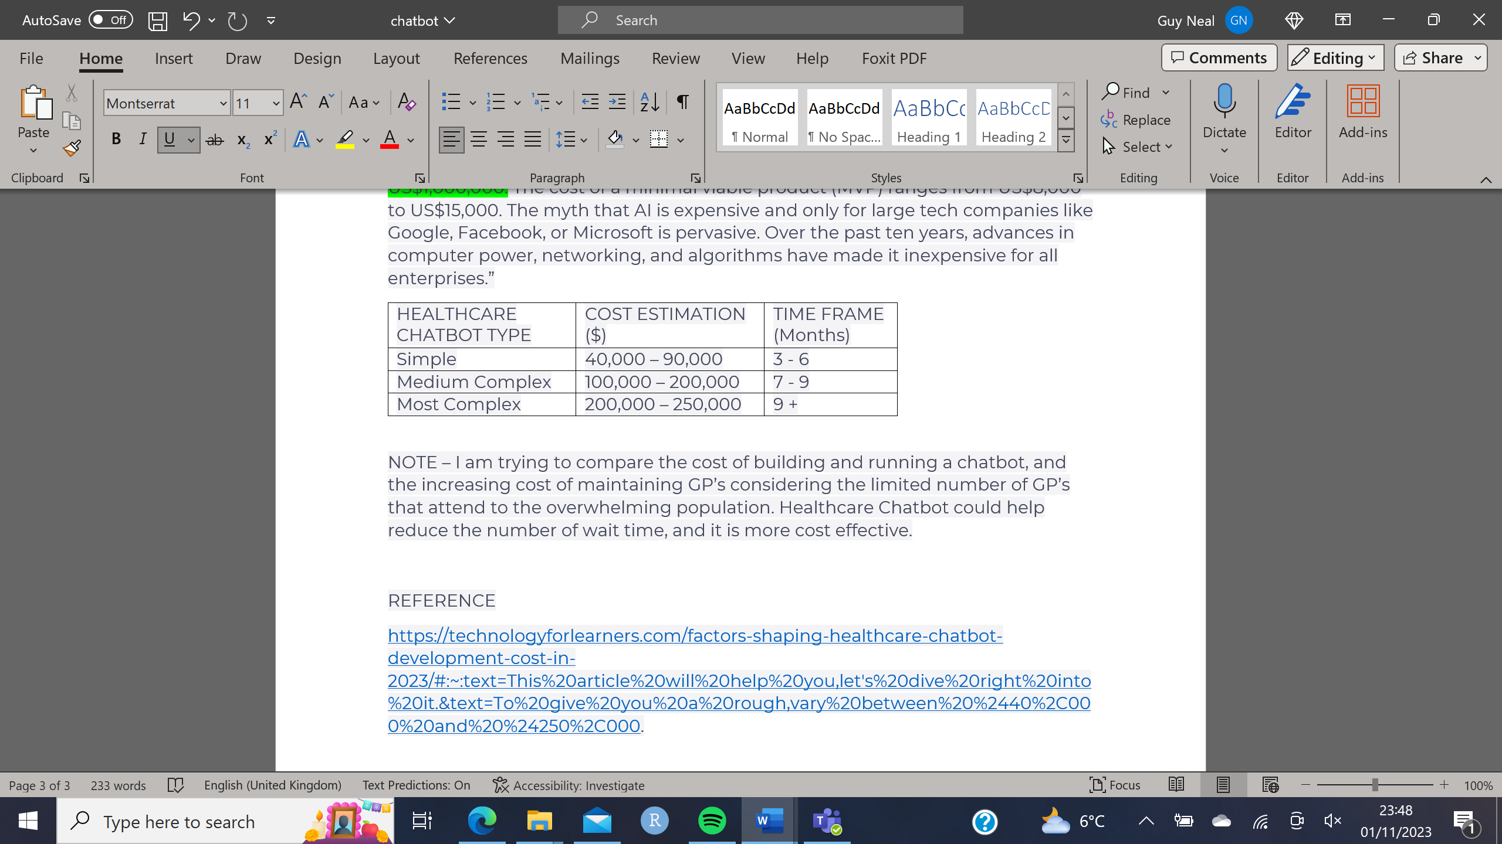

*Table 1. Estimated cost of AI systems over different timescales.*

# Bibliography

*Agnos: Your health companion that brings AI to diagnose symptoms* (2021). Available at: https://www.truedigitalpark.com/en/insights/articles/242/agnos-your-health-companion-that-brings-ai-to-diagnose-symptoms (Accessed: 2 November 2023).

Borowicz, D.M. *et al.* (2022) ‘Does CyberKnife Improve Dose Distribution Versus IMRT and VMAT on a Linear Accelerator in Low-risk Prostate Cancer?’, *Radiology and Oncology*, 56(2), p. 259. Available at: https://doi.org/10.2478/RAON-2022-0010.

Campbell, A. *et al.* (2022) ‘Generation Scotland - Using Electronic Health Records for Research.’, *International Journal of Population Data Science*, 7(3). Available at: https://doi.org/10.23889/IJPDS.V7I3.2041.

Cormstock Jonah (2019) *A ‘gold mine’ of data is driving Israel’s billion-shekel bet on digital health | MobiHealthNews*. Available at: https://www.mobihealthnews.com/news/emea/gold-mine-data-driving-israels-billion-shekel-bet-digital-health (Accessed: 2 November 2023).

‘Diagnostic Waiting Scotland’ (2022). Available at: www.publichealthscotland.scot (Accessed: 31 October 2023).

Flymedi (2022) ‘How much does cyberknife treatment cost?’ Available at: Available at: https://www.flymedi.com/blog/how-much-does-cyberknife-treatment-cost (Accessed: 2 November 2023).

Harrell Eben (2009) *In Denmark’s Electronic Health Records Program, a Lesson for the U.S. - TIME*. Available at: https://content.time.com/time/health/article/0,8599,1891209,00.html (Accessed: 2 November 2023).

ISD Scotland (2015) ‘An Official Statistics Publication for Scotland Publication Report Cancer Incidence Projections for Scotland’.

markets and markets (2022) *Healthcare Cloud Computing Market Trends, Growth, Drivers & Opportunities | MarketsandMarkets*. Available at: https://www.marketsandmarkets.com/Market-Reports/cloud-computing-healthcare-market-347.html (Accessed: 2 November 2023).

NHS Research Scotland (2023) *Electronic Health Records | NHS Research Scotland | NHS Research Scotland*. Available at: https://www.nhsresearchscotland.org.uk/research-in-scotland/data/sub-page-4 (Accessed: 2 November 2023).

Papatheofanis, F.J., Williams, E. and Chang, S.D. (2009) ‘Cost-utility analysis of the cyberknife system for metastatic spinal tumors’, *Neurosurgery*, 64(2 Suppl). Available at: https://doi.org/10.1227/01.NEU.0000341205.37067.DE.

‘Position Statement on Electronic Health Records in Scotland’ (2015).

*Scotland’s Census 2022* (2023) *Census Scotland*. Available at: https://www.scotlandscensus.gov.uk/2022-results/scotland-shttps://www.scotlandscensus.gov.uk/2022-results/scotland-s-census-2022-rounded-population-estimates/#section11-census-2022-rounded-population-estimates/#section11 (Accessed: 31 October 2023).

Scottish Government (2015) ‘A Health and Biomedical Informatics Research Strategy for Scotland’. Available at: http://www.gov.scot/publications/health-biomedical-informatics-research-strategy-scotland/ (Accessed: 2 November 2023).

*Topics | ISD Scotland* (no date). Available at: https://www.isdscotland.org/Health-Topics/ (Accessed: 2 November 2023).

Tov Moshe Bar Siman (2019) *How Israel Turned Decades Of Medical Data Into Digital Health Gold*. Available at: https://www.forbes.com/sites/startupnationcentral/2019/03/26/how-israel-turned-decades-of-medical-data-into-digital-health-gold/?sh=28e1b69b3ee4 (Accessed: 2 November 2023).

Valcke Christian (2020) *Leveraging Cloud Solutions in Point of Care Device Development*. Available at: https://www.invetechgroup.com/insights/2020/11/leveraging-cloud-solutions-point-of-care-device-development/ (Accessed: 2 November 2023).

wire business (2016) *Scotland Becomes First Country to Provide Electronic Health Record Privacy for All Patients | Business Wire*. Available at: https://www.businesswire.com/news/home/20160107005084/en/Scotland-Becomes-First-Country-to-Provide-Electronic-Health-Record-Privacy-for-All-Patients (Accessed: 2 November 2023).